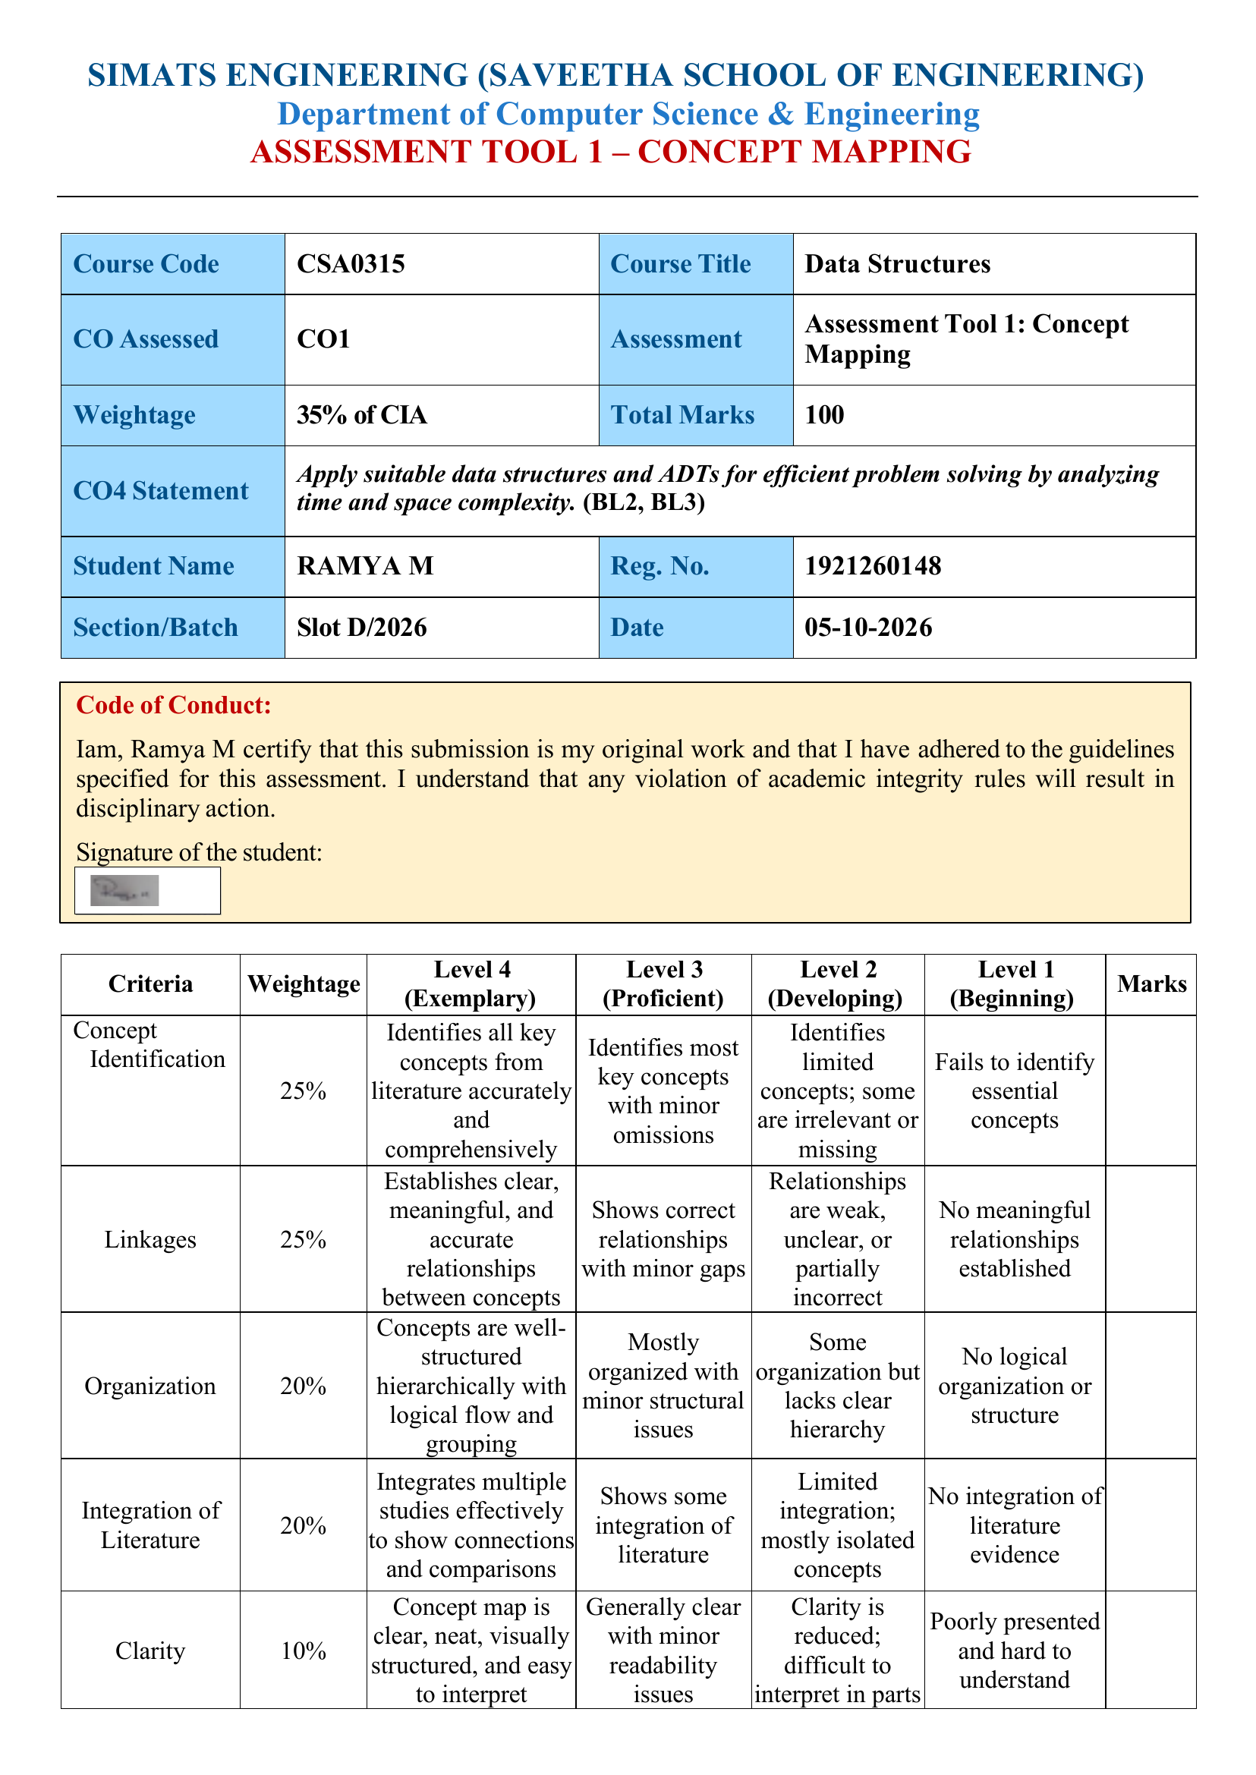

Question: A big data system processes millions of records. Construct a concept map connecting Performance → Time Complexity → Space Complexity → Throughput → Efficiency → Optimization. Analyze how performance metrics influence system design and justify optimization strategies.

